

**Master’s Degree in Computer Science**

**Academic year 2023/2024**

**WEB INFORMATION MANAGEMENT**

Usability analysis of

[**https://www.rottentomatoes.com/**](https://www.rottentomatoes.com/)

website



Author: **Michael Amista’**

Student ID: **2122865**

Period of analysis: **January-February 2024**

**Contents**

**1 Introduction** 5

**2 Rotten Tomatoes** 5

**2.1 What is Rotten Tomatoes?** 5

**2.2 Domain name** 6

**2.3 SERP positioning** 6

**3 Homepage** 8

**3.1 Informative axes** 8

**3.1.1 WHERE did the user arrive?** 9

**3.1.2 WHO is behind the website?** 9

**3.1.3 WHY should the user stay?** 10

**3.1.4 WHAT does the site offer?** 10

**3.1.5 WHEN? Is the website up to date?** 11

**3.1.6 HOW does the user arrive where he wants?** 11

**3.2 Menu** 12

**3.3 Searching** 13

**3.4 F-shape scanning** 15

**3.5 Scrolling** 17

**3.6 Text** 18

**3.7 Visual metaphors** 18

**3.8 Asking for personal data** 20

**3.9 Video player** 21

**4. Internal pages** 22

**4.1 Movies and TV shows** 23

**4.1.1 Informative axes** 23

**4.1.1.1 Mandatory axes** 24

**4.1.1.2 Optional axes** 24

**4.1.2 Structure and functionalities** 25

**4.1.3 Visual metaphors** 25

**4.2 Movie** 27

**4.2.1 Mandatory informative axes** 27

**4.2.2 Optional informative axes** 28

**4.2.3 Structure and functionalities** 29

**4.2.4 Visual metaphors** 30

**4.3 TV show** 30

**4.4 Shop** 30

**4.4.1 Informative axes** 30

**4.4.1.1 Mandatory axes** 30

**4.4.1.2 Optional axes** 30

**4.4.2 Structure** 30

**4.5 News** 30

**4.5.1 Informative axes** 30

**4.5.1.1 Mandatory axes** 30

**4.5.1.2 Optional axes** 30

**4.5.2 Structure** 30

**4.6 Search results** 30

**4.6.1 Informative axes** 30

**4.6.1.1 Mandatory axes** 30

**4.6.1.2 Optional axes** 30

**4.6.2 Structure** 30

**4.7 Handle of 404 error** 30

**4.7.1 Informative axes** 31

**4.7.1.1 Mandatory axes** 31

**4.7.1.2 Optional axes** 31

**4.7.2 Structure** 31

**5. Final evaluation** 31

**Figures**

Figure 1: SERP overview for "rotten" (22/01/2024) 7

Figure 2: Homepage 8

Figure 3: Footer 9

Figure 4: News section in the homepage 11

Figure 5: Menu 12

Figure 6: Usability problem in the menu 12

Figure 7: Search functionality 14

Figure 8: Search functionality of NEWS page 14

Figure 9: F-shape scanning on the homepage 16

Figure 10: Instance of visual metaphors in the homepage 19

Figure 11: Cookie banner for the first visit 20

Figure 12: Video player 21

Figure 13: Movies/TV shows webpage 23

Figure 14: Visual metaphors explanation on filter options 26

Figure 15: Movie webpage 27

# **1 Introduction**

Over the years Internet has become a powerful and useful tool able to connect information from different sources and providing it to everyone. The number of websites is consistently increasing day by day due to the high demand for information and services, but this information is not always simple to get.

There are many examples of websites with great purposes but badly designed which increase the users’ computational effort and make the navigation experience heavy. For all these reasons it’s important to study the usability of websites, a concept remarked in the following definition.

“Web usability is the discipline that studies how to design and then create a usable website.

A website is usable if it is easy to access and navigate, and if it satisfies the information needs of its users.”

The aim of the document is to analyse a real website to understand if it respects the usability principles that are so much important in the modern web. In this case the analysis is based on the Rotten Tomatoes website; for this study just the desktop version has been taken into consideration.

# **2 Rotten Tomatoes**

This section presents the Rotten Tomatoes website in terms of its purposes and share of information. It is also discussed about the choice of its apparently strange name and its SERP positioning.

## **2.1 What is Rotten Tomatoes?**

Rotten Tomatoes is a popular American review website for film and television. The website compiles reviews and ratings from critics and audiences to provide a consensus score for movies and TV shows.

The Tomatometer® is the primary metric used by Rotten Tomatoes to represent the percentage of positive reviews given by critics.

In addition to the Tomatometer®, Rotten Tomatoes also provides an Audience Score, which reflects the percentage of audience members who enjoyed the movie/TV show.

Rotten Tomatoes is presented as a useful tool for measure the overall reception of a film or TV show.

## **2.2 Domain name**

On average, the name of a website increases users’ satisfaction by 10% - 20%; so, a website name must be chosen appropriately, following some rules.

Even if “rottentomatoes.com” seems to be a strange domain name for a website, it works because it respects the main principles of a good name:

* it is short and so, it is easy to memorize and write;
* it is unique;
* it is formed by real words (“*rotten*” and “*tomatoes*”);
* it sounds well;
* it takes the “.com”, which is the top-level domain that a website can use.

An interesting fact is related to the origin of this name. The name "Rotten Tomatoes" is a reference to the tradition of throwing rotten tomatoes at a stage performer who delivers a poor performance.

Beyond these considerations it is also true that the name doesn’t represent the content of the site, probably because the website relies on its fame in the television community. Anyway, a general user, who does not know Rotten Tomatoes, cannot understand that it is a review website for film and television.

## **2.3 SERP positioning**

To study the SERP (Search Engine Results Page) positioning of the Rotten Tomatoes website, it has been used the online and freely available tool: <https://ahrefs.com/serp-checker> which simulates search engines behaviour over given keywords in different countries. For this test the selected country was “United States” since there have been considered, as possible searches, also the single words “***rotten***” and “***tomatoes***” which are common English terms not necessarily related just to this website.

Several tests have been conducted over more specific and less specific keywords and the observed results are interesting. For instance, searching for the specific name “**rotten tomatoes**” returns the website in first position; nothing surprising since the website has been searched by its own name.

If the website is searched just by “***rotten***” (**Figure 1**), which is a common English word, the website is yet in the first position, also higher than the vocabulary definition for that word, this shows the power of the site indexing.

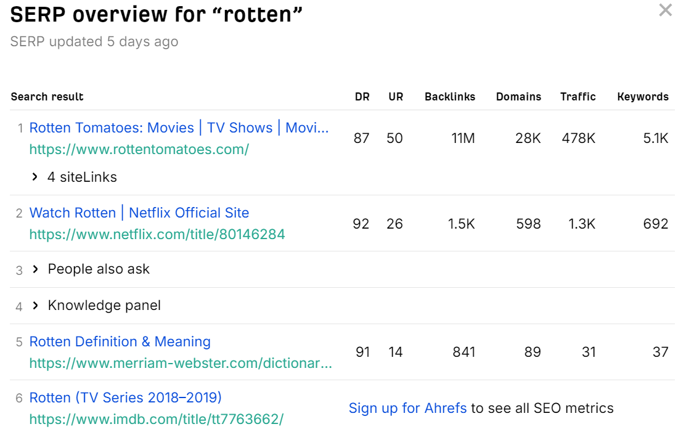

Figure 1: SERP overview for "rotten" (22/01/2024)

If the website is searched just by “***tomatoes***” (which is again a common English word) the website is in sixth position; not bad since the website has been searched by just a common word.

Then the website has been searched with other keywords that represent the content provided by Rotten Tomatoes. These searched keywords (with the relative position in SERP) were:

* “***film reviews***”: 2nd
* “***TV show reviews***”: 3rd
* “***best film***”: 3rd
* “***latest movies***”: 4th
* “***most popular TV shows***”: 8th
* “***matrix reloaded***”: 5th (tested with a real movie name)
* “***the big bang theory***”: 8th (tested with a real movie name)
* “***movies in theatres***”: 5th
* all the tried combinations with the keyword “***news***” never returned the website in the top ten of SERP.

Overall, the website is well indexed in the SERP and more time the website holds these positions more users’ flow it has.

# **3 Homepage**

There is a parallelism between a shop and a website, both tries to impress people by showing what they offer in their big windows.

A shop fails if it is not able to capture the curiosity of potential customers and so its flow is not so great. This is similar on what happens on the web.

The homepage of a good website should attract people; it’s the window of the shop and if the first visit goes not so well the website has failed and users’ return rate goes down. This is the reason why the homepage is so important for websites.

This section critically analyses the homepage of Rotten Tomatoes website (**Figure 2**) considering different usability factors.

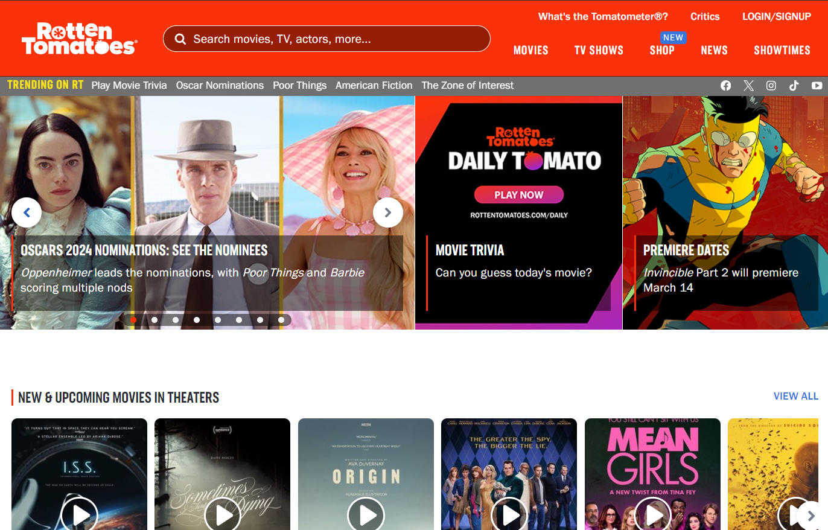

Figure 2: Homepage

## **3.1 Informative axes**

The informative axes provide a way to understand if the main information is clearly presented in the homepage of websites.

In fact, users try to extract this information from the homepage of a new website and if they are not able to get it, they generally prefer to go away. If a user chooses to stay or not only depends on how simple the page is to read.

The informative axes are six: WHERE, WHO, WHY, WHAT, WHEN and HOW. Each of the following sections critically analyses each axis.

### **3.1.1 WHERE did the user arrive?**

There are several voices in the menu, section titles and news (visible in **Figure 2**) which remarked that a user is arrived in a website that talks about movies and TV shows. This is good because a user can easily understand in which kind of website he is landed.

A user should also be conscious about his relative position on the website and it’s for this reason that a breadcrumb should always be present. In the homepage there is no breadcrumb, this could be acceptable since the homepage represents the first page of a website but in the deep linking scenario this is crucially important. In the internal pages analysis this fact has been considered deeply.

### **3.1.2 WHO is behind the website?**

Knowing the author of a website increases the users trust factor and this is not a superficial element, websites must consider it.

In the first part of the homepage (**Figure 2**), apparently, there are no information about the authors of the site. There is a voice that contains this information, which is the top right link “What’s the Tomatometer®?”; a bad choice because new users, that never really heard about Rotten Tomatoes, cannot know what the “Tomatometer®” is. Since the time is limited and precious, users do not try to get the WHO axis by a link that seems to not represent what they are looking for. Common users try to get this information searching in other zones of the homepage and, if the homepage is scrolled until the end, it turns out that the WHO axis is placed in the footer (**Figure 3**).

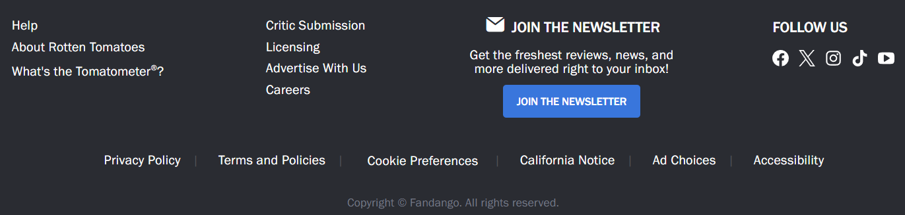

Figure 3: Footer

The highlighted box in **Figure 3** shows where the WHO axis is exactly placed: in the footer on the voice “About Rotten Tomatoes”.

Typically, new users scroll the homepage by 23% of its size so they typically never arrive to this information which is badly placed.

It is also possible to note that clicking on that link a user arrives exactly in the same page of the link “What is the Tomatometer®?” placed at the beginning of the homepage and previously discussed. In fact, this link points to another section of the same page of “About Rotten Tomatoes” link.

Apparently, authors give more importance to make clear which is their measure of judgment instead of explaining who Rotten Tomatoes is. This behaviour can be related to the fame of the website, but this in fact disadvantages new users.

### **3.1.3 WHY should the user stay?**

A well-designed homepage should persuade new users to stay on the website by showing them the advantages they would obtain continuing the navigation on the website.

Watching the homepage with and without scrolling this information seems to be missing. The homepage provides different ways to get information about movies, TV shows and news about them but there is no written motivation by which a user should stay on the website. Again, this can be related to the fame of Rotten Tomatoes and so authors may think it is not necessary to explain, for instance, why their movies/TV reviews are the best ones. In fact, this disadvantages new users, who never heard about Rotten Tomatoes, since they do not have any reason to stay.

### **3.1.4 WHAT does the site offer?**

From the homepage (**Figure 2**), particularly from the menu placed in the top part of the page, it is clear what the website is offering to users. Rotten Tomatoes provides information about movies, TV shows and news related to the cinema world. What is not so clear is that Rotten Tomatoes provides reviews of movies/TV shows.

Beyond the menu (which is deeper discussed in **3.2 Menu**), the WHAT axis can be also recovered by the main section titles of the homepage (“New & Upcoming movies in theatres”, “Popular streaming movies”, “New TV this week” and so on) and by the latest news carousel placed on the left.

Users who stay on the website will be able to know about the past and upcoming movies, TV shows and all the latest news.

### **3.1.5 WHEN? Is the website up to date?**

A user should always be able to understand if a website is up to date or not. The WHEN axis gives an answer to this question: a website should always provide latest news/contents.

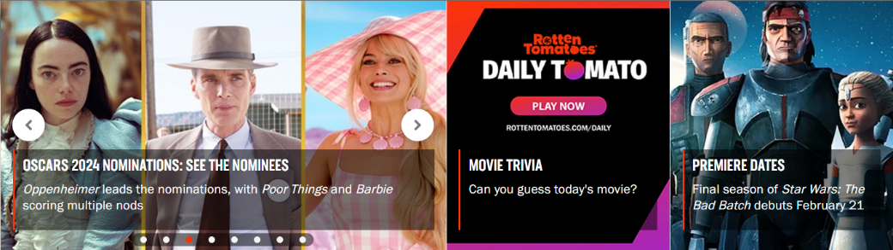

Figure 4: News section in the homepage

The homepage provides two different ways to get the WHEN axis:

* **a specific area under the main menu** (**Figure 4**) that shows to users the latest news uploaded on the website. The single news is formed by an image, a title and a blurb (a small summary of the news itself); all these parts are clickable and, if clicked, redirect user to the relative article page where he can get more information about the selected news.
* **the menu voice “NEWS”** which redirects users to the dedicated news section of the website.

### **3.1.6 HOW does the user arrive where he wants?**

A user should always be able to easily navigate on the website and collect all the information provided by the website itself.

All the Rotten Tomatoes reachable pages are provided by the top menu which a user can use to easily move on the website.

There is also a search functionality which users can use to obtain information in a simpler and fast way. The search functionality provided by Rotten Tomatoes can find information about movies, TV and celebrities without searching manually for them; the search-bar, if provided, highly reduces the users’ computational effort to obtain information and for this it’s really appreciated tool. The search functionality is deeper discussed in **3.3 Searching**.

## **3.2 Menu**

The purpose of a menu is to show to users all the possible destinations, all the reachable pages of the website which a user can visit to collect different type of information.

Rotten Tomatoes provides a menu which is placed in the top part of the homepage, as show in **Figure 5**. The menu is correctly placed since it is immediately visible from users who land on the website.

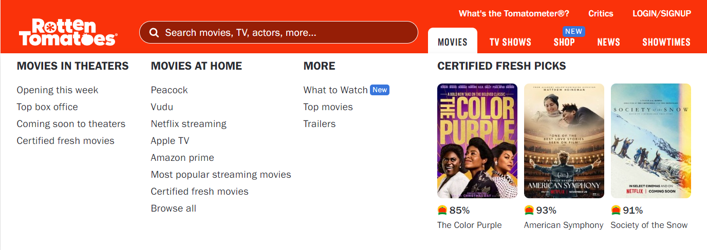

Figure 5: Menu

The menu is formed by five voices: “Movies”, “TV Shows”, “Shop”, “News” and “Showtimes”. Each menu voice represents one of the five macro areas of the website, then each area is a collection of pages related to the higher level of the tree shape of the website.

Excluding the menu voices “Shop” and “Showtimes”, if a user points the mouse cursor over one of the other menu voices a new area is displayed, as shown in **Figure 5**. This kind of sub-menu shows a small preview of the contents provided by the menu voice on which the user is landed with the mouse cursor.

This is implementation is interesting because a user can get a preview of other webpages contents before visiting them and, eventually, he can directly visit deeper pages provided by this new sub-menu.



Figure 6: Usability problem in the menu

Anyway, this sub-menu has a usability problem that can annoying users. In fact, if a user is interested in one of the links provided by this new menu he typically follows the fastest path to reach what he wants; these paths are represented by all the red lines in **Figure 6**. In this way the links positioned on the centre/right area has no problems (normal red lines) but the more left positioned links (represented by the dashed red lines) are never reached because the sub-menu will close itself before reaching the link of interest.

This happens because, to keep the sub-menu opened, the user should move down the mouse cursor until he reaches the beginning of the new menu area and then, if he remains inside this area, he can follow whatever direction he wants to reach the links.

This behaviour increases users’ computational effort to use the sub-menu functionality and it is known that users prefer easy things, represented by the red line ideal paths already discussed.

Another aspect badly handed is related to the “SHOWTIMES” menu voice, which enables users to book cinema tickets. This feature is only available in the United States so users who try to access to that feature outside the United States will see an error page that tell them about the problem. This is not good because user expectations are broken and if a functionality is available in just few countries, it must appear just on users who navigate in those countries!

## **3.3 Searching**

As already mentioned before, Rotten Tomatoes provides a search functionality which is much appreciated by users because they can collect information just searching for what they want without go through many pages. The search-bar is well placed in the top part of the homepage (**Figure 2**), in this way it is immediately visible by incoming users.

Anyway, it is possible to observe that the search-bar does not respect the web standard which corresponds to a “search” label on the left and a search button (typically an icon) on the right. In fact, the search button on the left, as in this case, creates a delay of 2 seconds and on the web every second is precious. For this reason, the choice of design used here is not so effective.

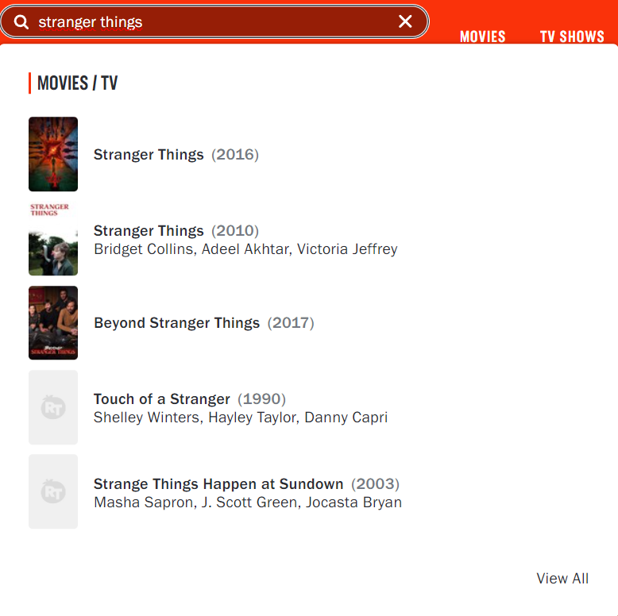

Figure 7: Search functionality

In particular, the functionality provided in the homepage enables users to search for movies, TV shows and actor/actress. While the user is typing on the search-bar there are displayed partial results corresponding to what the user has digited until that moment (dynamic search); this is appreciated since it helps users to find what they are looking for. So, users can click on the suggested links (both image and text are clickable) or they can press the search button to search what they want.

A curious observation is that the search functionality is available in every page which is appreciated by users because they can use it wherever they are, but the search-bar design and behaviour is not equal in all the Rotten Tomatoes webpages. In fact, the provided search-bar in the “NEWS” page and all its subpages is completely different, as it is shown in the **Figure 8**.



Figure 8: Search functionality of NEWS page

As it is possible to observe, this other search-bar respects the web standard compared to previous discussed version which is provided in all the other pages that are not under the NEWS area.

On the other hand, this second version does not provide any suggested link mechanism with partial information digited (static search) and this is bad: it has an upgraded design but a downgraded behaviour. The main question about this choice is just “why?”. Also note that the purpose of the search is the same of the homepage version: search for movies, TV shows and actor/actress. There are no valid reasons to provide the same functionality which is presented in different ways and with a different behaviour. This just confuses and disorientates users. A bad choice of implementation.

Talking about the search-box, the recommended average length is 30 characters, in fact this measure satisfies 90% of users. Over the years the number of keywords entered by users to search for something is increased; so, websites that provide a search functionality must be careful about the length of the search-box which is not a random number.

The dynamic version of the search (**Figure 7**) has a length of 42 characters while the static version (**Figure 8**) has a length of 37. Both versions provide a good length and this is appreciated by users. Beyond these numbers, the digited content is not entirely visible and users must scroll to see what they have written in the hidden part; since the two lengths follows the average search-box length this is not consider as a problem.

The output page provided by the search functionality is discussed in **4.6 Search results** as it has been considered as an internal page to analyse deeply.

## **3.4 F-shape scanning**

The F-shape pattern refers to the typical eye movement pattern that users exhibit when scanning a webpage. The pattern is characterized by users scanning the content in a manner that resembles the letter "F".

The webpage is scanned in the following order:

1. First, users move their gaze in a horizontal direction to the top of the content area. They thus create the upper bar of the F.
2. The second step is to move vertically by scrolling the page, stop at a point of attraction and continue reading horizontally for a shorter stretch than the first. Here is the second bar of the F.
3. User concentration remains focused on the left side, searching for possible points of attraction which are scanned in a horizontal movement that covers a shorter area than the previous horizontal scan.

The F-shape pattern highlights the importance of placing crucial information in the most viewed areas of the webpage to capture the users’ attention quickly.

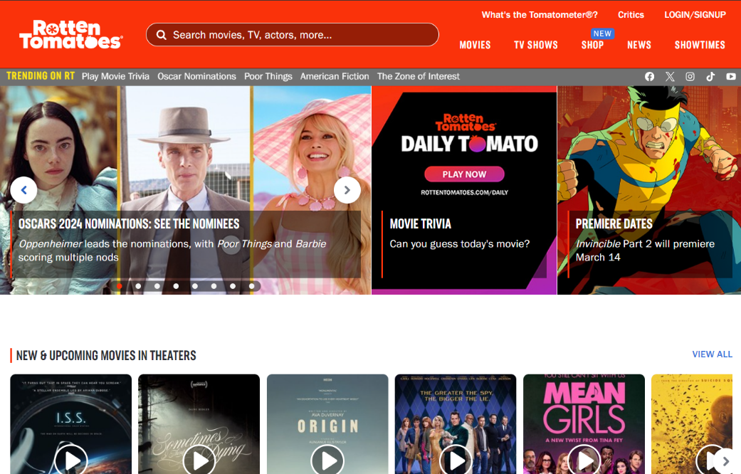

**3**

**2**

**1**

Figure 9: F-shape scanning on the homepage

The **Figure 9** provides a simulation of the F-shape reading pattern on the homepage of Rotten Tomatoes.

Users start to scan the homepage from the top-left corner (the typical entry point of a website) where the Rotten Tomatoes logo is placed; this is important because the logo of a website represents its identity and it should be the first thing that a user sees when he lands on a website. Beyond the logo users scan the entire top area of the page so it is important to choose appropriately the information to place here. Rotten Tomatoes does it by placing the search-bar, the menu and other interesting links on the top area. In this way, by the first horizontal line of scan, a user obtains the identity of the website, the presence of a search functionality (that can help him) and the structure of the website menu.

More the user moves down on the page less long the horizontal reading lines become; so, it is crucial to place the information in a way where the most important parts are always reached.

In the case of the homepage a user can capture the main information also with a less long horizontal line. In fact, it is possible to observe that the second and third horizontal lines can capture the main content of the relative areas. From the second horizontal line a user can get almost the whole WHEN information and with the third one a user can get the relative section title and the first part of its content.

When the first part of the homepage has been entirely scanned, the user can scroll the homepage to reach the remaining parts. Every new scroll leads to a new F-shape which reiterates the whole procedure.

Overall, the entire homepage content follows the F-shape reading pattern and this is appreciated since the arrangement of content has been based on one of the most used reading patterns by users on the web.

## **3.5 Scrolling**

Another usability problem is related to the scrolling. In fact, this operation requires computational effort and for this reason it is better having not so much scroll on the provided pages. On average, users are used to scroll 1.3 “screens”, they hardly see what there is beyond.

There are two types of scrolling: vertical and horizontal. The vertical one is the best one since it is the commonly used in the web navigation. The horizontal scrolling is to avoid at all costs because it is uncommon; in fact, it introduces a new axis to manage and this leads to more computational effort requested by users.

The Rotten Tomatoes homepage requires 8-10 vertical scrolls to be entirely seen; this is not so effective since the homepage is long and the computational effort required to see it entirely is high. The problem is not about big images that occupy great portions of the screen, which is a persistent problem on the web, but on the quantity of content that the homepage provides. It is also true that a user can obtain the main information of the homepage by the first 2-3 scrolls and then it is his choice to continue or not the inspection. The homepage in fact is just a big summary of the internal pages, with different lists of movies and TV shows in tendency in that moment; for instance, a list of movies currently available in theatres, a list of TV shows available on a specific streaming platform and so on. This “lost” information, over the 2-3 scrolls, can be recovered inspecting internal pages where users generally scroll more, on average about the 42% compared to the 23% of the homepage.

In the maximized browser window there is no evidence of the horizontal scroll but if the window is reduced, then the horizontal scroll appears (for instance with 980px x 700px). This is bad because users who works on the web with a not maximized browser window has to manage a bidimensional space. In fact, a user has to scroll also the horizontal axis to see what there is beyond the frizzed horizontal part.

## **3.6 Text**

The text is another important aspect to consider when talking about usability of a website. The provided text should not be too much in term of quantity since users have not the time to read walls of text and it should be readable and clear.

The Rotten Tomatoes homepage does not provide so much text, so in term of quantity this is respected. The text is readable since it is well written and the font used is quite good.

The text is not resizable, in fact this can disadvantages some users who are not comfortable with the provided size.

The contrast is quite good, in fact there is a classic black text over a white background so users should be able to easily read it.

## **3.7 Visual metaphors**

The visual metaphors problem is related to some website elements on which a user has not expectations since he is not able to understand their meaning or functionalities; in fact, these elements cannot provide any useful information because they are not understood by users.

Rotten Tomatoes has some visual metaphors which are not directly explained where they are present; in fact, the most important information which Rotten Tomatoes website provides becomes useless.

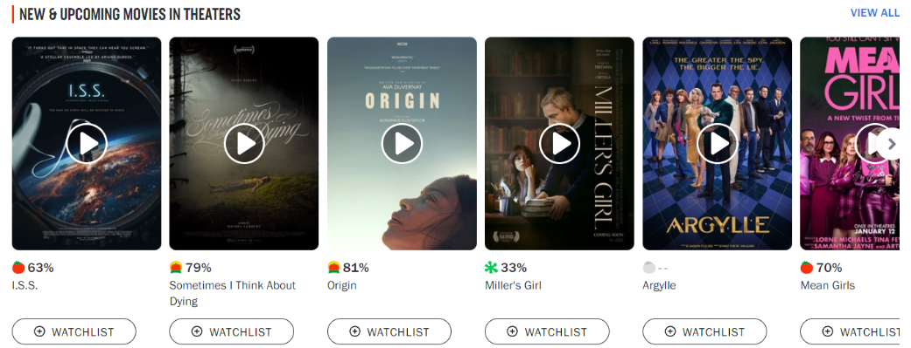

Figure 10: Instance of visual metaphors in the homepage

The **Figure 10**, extracted by the homepage, shows the nature of the problem. It is possible to note that every product reviewed by Rotten Tomatoes, a movie or a TV show, is associated to a specific percentage with a relative icon. This percentage/icon couple surely has some meaning since it has been inserted in the content of the page; so, the question that a user who never heard about Rotten Tomatoes make itself is “What does this information means? What is it?”. Users try to search around for some explanation without finding anything.

The answer is provided by a link inserted in the top of the page called [“What is the Tomatometer®?”](https://www.rottentomatoes.com/about#whatisthetomatometer) (visible in **Figure 5**). If a user clicks on this link, he discovers the meaning behind these mysterious percentages and icons. In synthesis these %s/icons represent the quality of a product in Rotten Tomatoes’ opinion by showing a red tomato when a product is sufficient and a rotten tomato when the product is disappointing. The tomato is a metaphor which represents the freshness of a product, a good film is fresh and a disappointing one is rotten. It sounds great, finally the explanation appeared, but it is not so great.

In fact, users who have never heard about this website and so about the famous “Tomatometer®”, typically do not click on this link because, as discussed in “**3.1.2 WHO is behind the website?**”. The text of the link is not much expressive about its content and since the time on the web is limited and precious users do not spend time over a link voice that seems to be useless.

There is also to note the crucial importance of the page “What is the Tomatometer®?”. In fact, this page provides precious explanation to better understand the content of the site, with much more icons used in the website compared with the ones shown in **Figure 10**; so, if this page is skipped, it creates a chain reaction that can lead to a losses of new potentially users.

Again, this behaviour can be related to the fame of the website but in fact new users are clearly disadvantaged.

All the other visual metaphors present on the website, like the social media ones, are easily understandable by users.

## **3.8 Asking for personal data**

The first time on which users visit the website by passing to the homepage or one of internal pages, a large cookie banner appears on the bottom part of the page, as show in **Figure 11**.

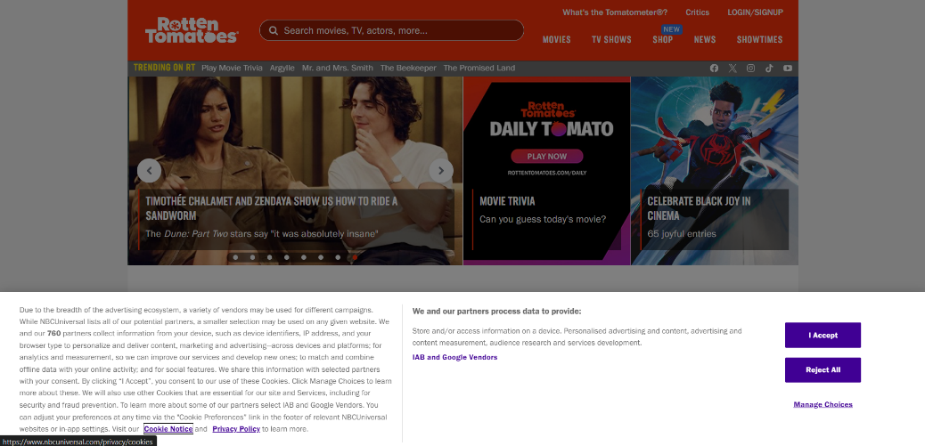

Figure 11: Cookie banner for the first visit

All the web elements as pop-ups, alerts or banners are hated by users because they are distractive elements; in fact, a banner, as in this case, is placed between the user and the content of the webpage. The time that a user takes to close the banner is subtracted from the already limited time which a user spends on a website, if the user chooses to stay.

At least in this case, the modality to close the banner, “Reject All” button on the right side, is simple but the banner is too invasive.

Users can use the login, signup and newsletter functionalities but these are his choice and the website does not force him in any way.

The login is useful to unlock functionalities like the one provided by the “+ WATCHLIST” button in **Figure 10** which enables users to create their own personal watchlist with movies and TV shows present on the website.

Another interesting functionality provided by the login is the possibility to write your personal review of a specific Rotten Tomatoes product. This personal review is averaged with all the other users reviews to create the so-called “Audience Score”. Rotten Tomatoes found an effective way to involve users, creating a community, who can always create new website content.

## **3.9 Video player**

If correctly used, videos can power up a website since they provide a source of information with almost a zero computational effort required by users.

As mentioned before, part of the homepage is a big summary of the reviewed products which a user can find on the Rotten Tomatoes website. These products are divided in different lists (like the one in **Figure 10**) as “Movies”, “TV shows”, “Now in theatres”, “Now in streaming” and so on.

For each element in these lists Rotten Tomatoes also provides a short trailer. In particular, from the **Figure 10**, it is possible to note a video player icon which, if clicked, make it appears a small window which shows the trailer of the product on which the user has clicked.

Talking about the icon which make it plays the video, there is no problem with visual metaphors because the chosen icon is quite standard on the web and so, a general user can expect that a video will be played.

A more detailed discussion can be made on the type of the video player used.

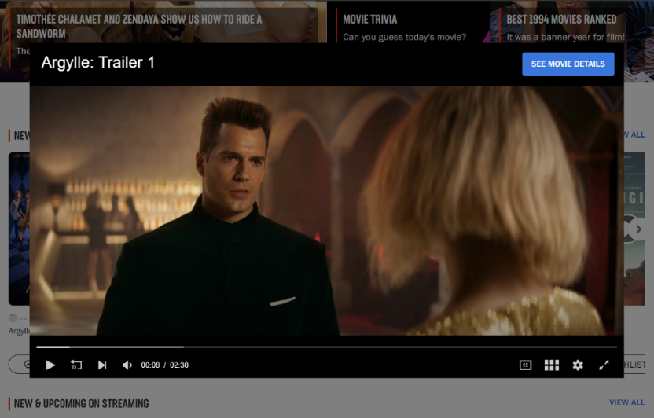

Figure 12: Video player

Once the user has clicked on the video player icon, a new window is displayed, as shown in the **Figure 12**.

Rotten Tomatoes provides its own version of the video player instead of using a non-proprietary mechanism like the one provided by YouTube. In some websites, which do not own the resources to also manage the video sharing, using proprietary mechanisms could be a problem because videos can have a delay or users are not able to manage them properly. The video player provided by Rotten Tomatoes does not have these types of problems. In fact, there is no long uploading time since the video player reproduces the video considering users’ network features and so, the video is played in a specific quality according to the users’ constraints.

The controls are quite standard, with icons and functionalities that are present in the most used video players. In fact, a user can easily stop and resume the video, turn up and down the volume, watch the video in full screen size and so on.

As it is possible to observe in **Figure 12**, there is an interesting button named “SEE MOVIE DETAILS” which redirects users to the movie page with all the deeper information about the product. This is appreciated since if a user is interested in a product after seen the trailer, he can directly land on the product page which describes the movie or TV show more in detail.

What is not so effective is the way to close the video player. If the **Figure 12** is observed, apparently there is no icon/way to close the video. This can confound users who, since they have no idea on what to do, typically just close the page or press the back button; in fact, these operations are the once with the lowest computational cost and so, for users, close the page is the easiest alternative compared with try to understand what to do when this is not explained. The “correct” way, provided by the website, to close the video is to click out of the video player but this behaviour is not so intuitive.

# **4. Internal pages**

This section proposes a critically analysis of the main internal pages of the Rotten Tomatoes website. In detail, the internal pages discussed are the following:

* the menu voices: MOVIES, TV SHOWS, SHOP, NEWS;
* the search results page;
* the handle of the 404 error.

Due to the reasons already discussed in **3.2 Menu**, the menu voice “SHOWTIMES” has not been considered in this section.

## **4.1 Movies and TV shows**

Since the webpage under the menu voices “MOVIES” and “TV SHOWS” is the same with just different filter options applied, these menu voices have been considered together in the analysis, so as a single webpage.

The webpage “MOVIES / TV SHOWS” (**Figure 13**) represents the collection of all the movies and TV shows reviewed by Rotten Tomatoes during the years and for which a user can find the related information.

Since the reviewed products are many, Rotten Tomatoes beyond the search, which remains available in the top part of the page, provides some filter options. In this way users can easily find what they are interested in by favourite genre, audience score and so on.

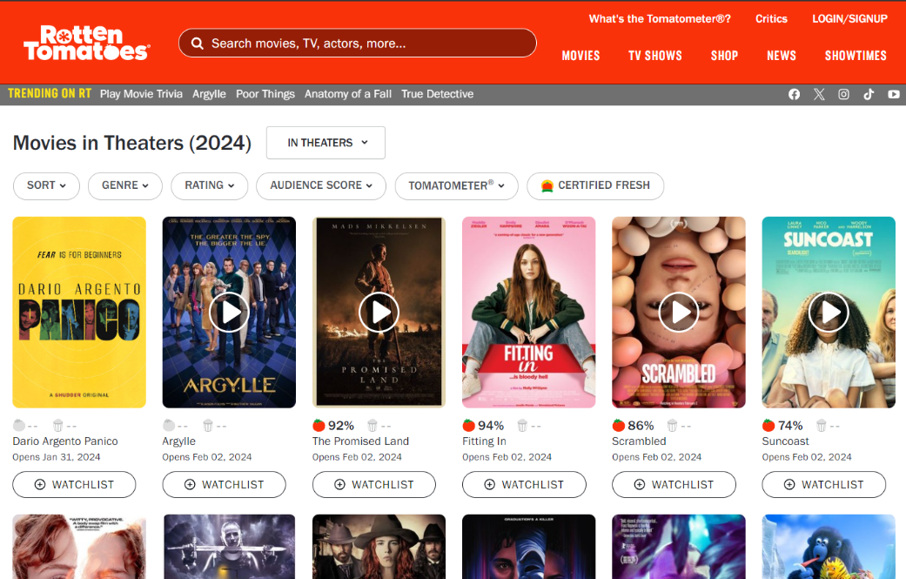

Figure 13: Movies/TV shows webpage

### **4.1.1 Informative axes**

Since in our days the navigation on a new website can start from every page (homepage or internal ones), websites must consider that users can view internal pages before the homepage. Since this scenario can happen (think about what the search engines do with indexing) even the internal pages must provide to users the main information about the website.

As discussed before with the homepage, this information is represented by the six informative axes. Different from the homepage scenario, in internal pages some axes become mandatory and others completely optional, but if present they are appreciated by user.

#### **4.1.1.1 Mandatory axes**

**WHERE** From the menu voices and the content of the page it is clear that a user is arrived in a website which talks about movies and TV shows. What is not so clear is that the website talks about reviews, in fact this information can be extracted by the filter options but only if the user tries to use them and so not during the scanning phase.

Since this page represents a possible deep linking scenario a breadcrumb is necessary to make user know about his relative position on the website. Here there is no breadcrumb and this can lead to the “lost in navigation” phenomenon.

**WHO** Here there is the same problem discussed about the homepage and related to the wrong choice of name link “What is the Tomatometer®?” (better discussed later) which is ignored by users. In fact, users who never heard about Rotten Tomatoes cannot get the WHO axis by the logo and so, they try to search in other parts of the page without finding anything. The answer is again placed in the footer under the voice “About Rotten Tomatoes”.

**WHAT** This information can be extracted from the menu voices by which it is possible to understand that Rotten Tomatoes provides information about movies, TV shows and latest news about the cinema world. Again, what is not so clear is that Rotten Tomatoes provides reviews on these products certifying their quality or insufficiency.

#### **4.1.1.2 Optional axes**

**WHEN** As it is possible to observe from **Figure 13**, there are several textual contents which claim the temporal aspect. In fact, this information can be retrieved by the title of the page and the dates under each product in the displayed collection.

**WHY** The website does not try to persuade new users to stay on Rotten Tomatoes with a written motivation. As discussed for the homepage scenario, this behaviour can be related to the fame of Rotten Tomatoes in the television community but again, this disadvantages new potential users.

**HOW** Users can easily land in the other Rotten Tomatoes webpages to collect other information by using the menu and the search, both available in the top part of this page.

### **4.1.2 Structure and functionalities**

The “MOVIES / TV SHOWS” page presents the collection of the all the products reviewed by Rotten Tomatoes, presenting them in a grid of elements. Typically, the grid layout tends to confuse users due to the non-linear path to explore the contents but there is also to note that Rotten Tomatoes provides a movies/TV shows database really great so, using a list layout is not so effective since the page will become really long to scroll.

Since the products are a lot, at the beginning of the page there is also a filter functionality able to show products under certain conditions as: currently in theatres, available at home, coming soon, TV shows, genre, streaming platforms and so on. This functionality is useful for users because it saves much of their time and, as observed before, this is a fundamental aspect to consider.

Also in this page, as discussed in **3.9 Video player**, there are some grid elements which present the video icon that, if clicked, opens the same video player already talked about.

### **4.1.3 Visual metaphors**

As discussed in **3.7 Visual metaphors**, in part even this webpage suffers about the visual metaphor problem. In fact, as it is possible to observe from **Figure 13,** similarly on what happens in the homepage, every product in the grid collection is associated with a percentage and an icon. This information is not directly explained where it appears but, differently from the homepage, in this case there are further considerations to do.

There is to note that the already discussed menu link “What’s the Tomatometer®?” is available also in this page and here it has a little bit of sense.

Since one of the filter options is called “Tomatometer®”, a user who does not know what it means he can discover it in two different ways, using:

1. the top menu **link “What’s the Tomatometer®?”**. This is the option that requires more computational effort since a user, who has seen the filter option called in the same way of the menu link, should move the mouse cursor from the filter menu to the top menu of the page. Anyway, this option seems to be the “more secure” one since a user can be surer that clicking on that link he will obtain the answer he was searching for;
2. the **filter option “Tomatometer®”** (**Figure 14**). This is the option that requires less computational effort since the user is already there and he can simply try to click on that option and hope for some explanation. In fact, this is the “less secure” option since the user has no warranties if in this way he will find the answer or not.

The same operations can be replicated to also discover the meaning of “Audience score”, another visual metaphor (**Figure 14**). In fact, also this information is contained in both the Tomatometer® dedicated page and in the relative filter option.

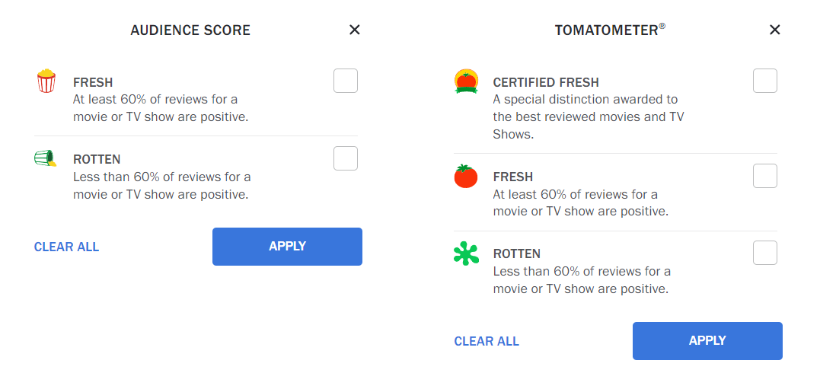

Figure 14: Visual metaphors explanation on filter options

The idea behind these icons is even interesting but the explanation is not so easy to find. In fact, none of two modalities previously discussed is effective at 100%. The visual metaphors should be intuitive or if they are not, they must be explained in the simplest possible way and here finding this information is not easy.

## **4.2 Movie**

The movie page, shown in **Figure 15**, represents the page related to a specific movie reviewed by Rotten Tomatoes. This webpage provides all the information related to the movie itself as plot, cast, videos (if present), photos (if present) and the critics/public score (if the movie has been already published by the relative film production house).

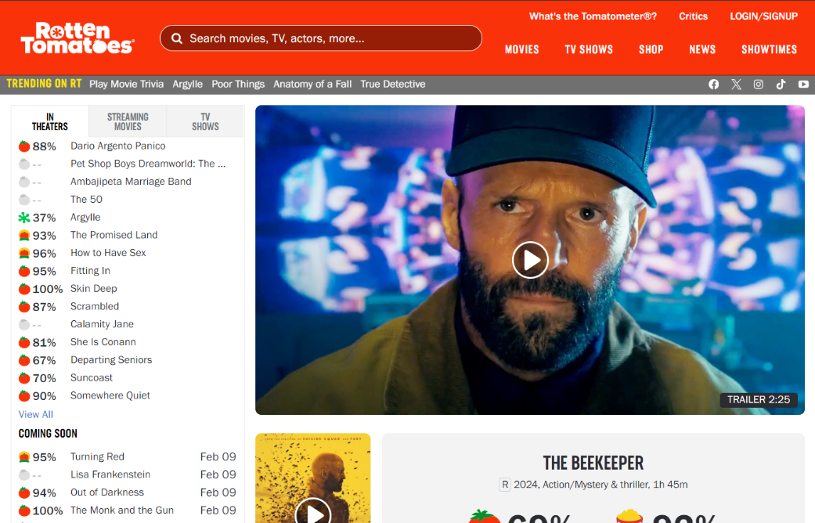

Figure 15: Movie webpage

### **4.2.1 Mandatory informative axes**

**WHERE** The menu is always a useful element to understand the content provided on the website where a user lands. From the menu voices a user can understand that he arrived on a website which talks about movies, TV shows and news related to the television world.

As in the movies/TV shows page, also here there is no breadcrumb which is a fundamental tool used by users to understand about their relative position on the website. Even in this case the “lost in navigation” phenomenon occurs.

For users, it is not so easy to understand that they landed on a specific movie page since the user attention zones (F-shape scanning) are not exploited in the best of ways. In fact, after seen the top menu and all the other links in the top area, the user concentration focuses on the list of movies (visible in **Figure 15**), immediately positioned on the left area under the menu. This list provides some entry points that users try to scan horizontally. In this way, the right content is obscured by the list of movies on the left. So, the content of the movie page is badly provided because the right content is never reached by users who lose the most important information of the page: movie title, other info and ratings (with the already discussed visual metaphors problem).

At the end a user, who lands on this page by the SERP indexing or clicking on a specific movie in other pages of the website, receives as the main information a list of movies different from the one he was looking for, creating disorientation and confusion.

**WHO** Typically, users try to get this information by the logo of a website but here the logo does not give any relevant information for users who do not know who Rotten Tomatoes is.

The problem is the same of the homepage scenario, discussed in “**3.1.2 WHO is behind the website?**”, where the badly choice for the name of the link “What’s the Tomatometer®?” makes this information hard to find. It is also true that this name for the link can be useful for other elements present in the page under the voice “Tomatometer®” because, since this information is not explained where it appears, a user may find the explanation searching on the top of the page.

**WHAT** This information can be extracted from the menu voices, positioned in the top part of the page. What is not so clear is that Rotten Tomatoes provides reviews on movies and TV shows, certifying their quality or insufficiency. Then there is also the problem discussed for the WHERE axis; in fact, for a user is hard to understand that the movie page provides information about the movie which user was looking for. There is to note that there is a huge image of the film that the page describes but, in fact, users delete all the images during the scanning phase, preferring the textual information. So, this image does not help users in any way.

### **4.2.2 Optional informative axes**

**WHEN** The first element, which partially answer to this question, is the “NEWS” voice of the menu. In fact, a user can visit the news page to get the latest news provided by the website. Then, if the page is scrolled more than once, there are different parts on which users can recover the WHEN information; areas as the reviews one, on which a user can view the reviews trend for that movie during the time.

**WHY** This page, as the whole website, does not provide any type of motivation by which users should stay on Rotten Tomatoes. One reason, already mentioned, could be related to the fame of Rotten Tomatoes in the television community but this is not enough because new users are penalized.

**HOW** Even this page provides the main functionalities by which users can collect different information in the whole site. The search and the menu, previously discussed, remains available in the top part of the page.

### **4.2.3 Structure and functionalities**

Over the problem introduced by the previously discussed list of films, the movie page (**Figure 15**) is not structured in the best of ways. In fact, even if there wasn’t this list, there is a problem about the order of the information.

The first element which a user sees is a huge image which provides the video trailer of the movie with the same modalities discussed in “**3.9 Video player**”. This element can be ignored by users who do not have so much time or they just prefer to avoid videos, so this information placed at the beginning of the page is not so useful. Then there is the title of the film, the information about critics and public ratings (with the visual metaphors limitations), again other movies a user may like and the information about where it is possible to watch the film (theatres/on streaming).

In fact, a user, who scrolls the page until this point (four scrolls), does not already have any idea about the general movie information, which is a section placed after all these elements. This “missed” textual information is placed in the beginning of the page but under a video source and there are no warranties that all users watch the video to recover this information which is placed much after in the content. Reaching this information requires a greater computational effort for users who do not know the film and who are therefore not only interested in the reviews but also want to discover something more about the movie. This should take into account.

PERSONAL REVIEW, VIDEOS, PHOTOS, MOVIE INFO, NEWS.

### **4.2.4 Visual metaphors**

…

## **4.3 TV show**

## **4.4 Shop**

### **4.4.1 Informative axes**

#### **4.4.1.1 Mandatory axes**

#### **4.4.1.2 Optional axes**

### **4.4.2 Structure**

## **4.5 News**

### **4.5.1 Informative axes**

#### **4.5.1.1 Mandatory axes**

#### **4.5.1.2 Optional axes**

### **4.5.2 Structure**

## **4.6 Search results**

### **4.6.1 Informative axes**

#### **4.6.1.1 Mandatory axes**

#### **4.6.1.2 Optional axes**

### **4.6.2 Structure**

## **4.7 Handle of 404 error**

### **4.7.1 Informative axes**

#### **4.7.1.1 Mandatory axes**

#### **4.7.1.2 Optional axes**

### **4.7.2 Structure**

# **5. Final evaluation**